**Name:** Kanishk Vardhan Singh

**Superset ID:** 6363335

***React JS***

1. **Create a new React Application with the name “myfirstreact”, Run the application to print “welcome to the first session of React” as heading of that page.**



App.jsx

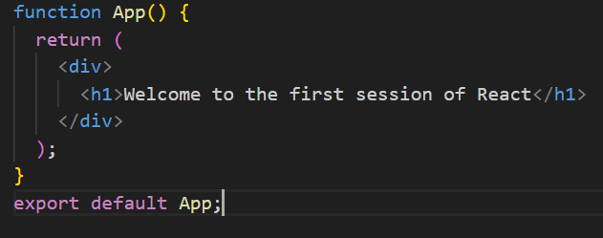

1. **Create a react app for Student Management Portal named StudentApp and create a component named Home which will display the Message “Welcome to the Home page of Student Management Portal”. Create another component named About and display the Message “Welcome to the About page of the Student Management Portal”. Create a third component named Contact and display the Message “Welcome to the Contact page of the Student Management Portal”. Call all the three components.**



Home.jsx

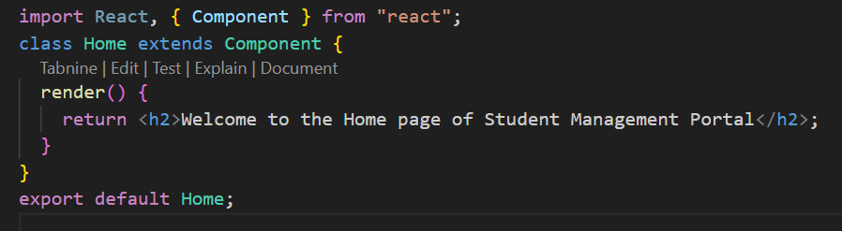

App.jsx

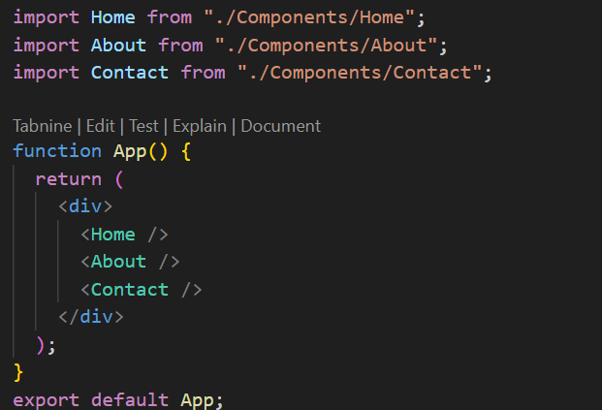

1. **Create a react app for Student Management Portal named scorecalculatorapp and create a function component named “CalculateScore” which will accept Name, School, Total and goal in order to calculate the average score of a student and display the same.**

Score.jsx

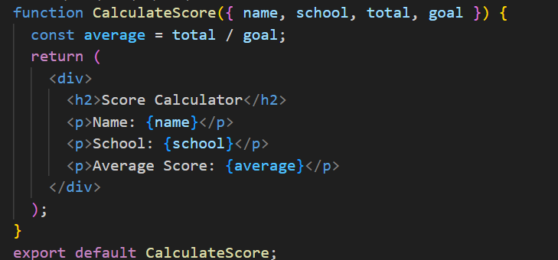

App.jsx

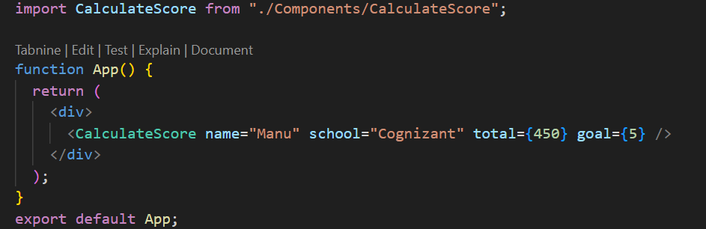

**4.**



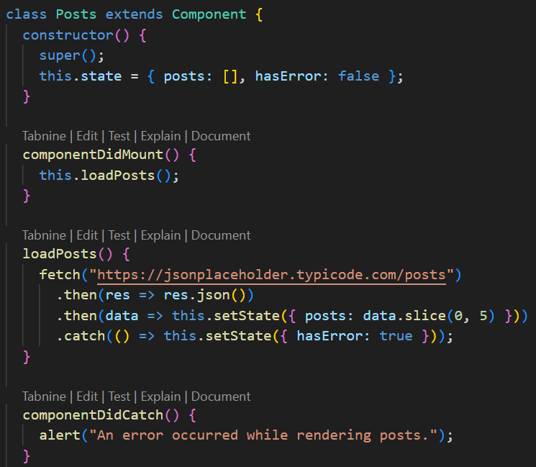

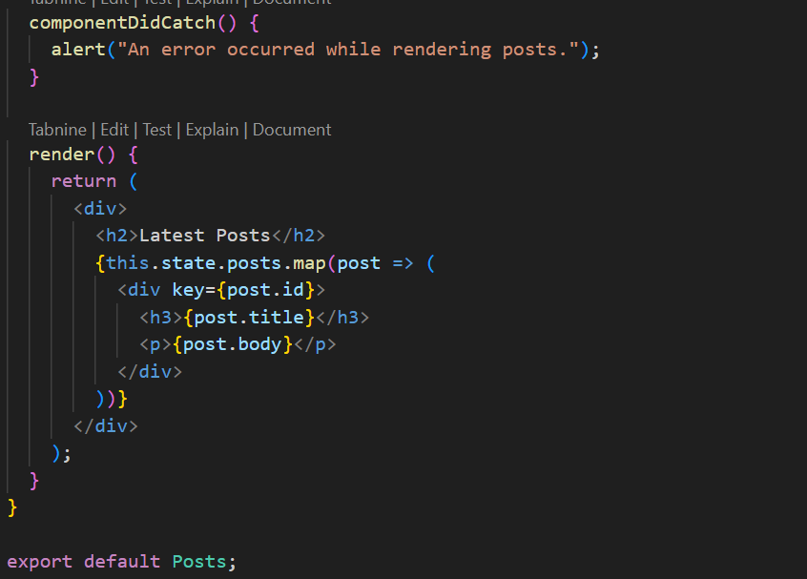

App.js

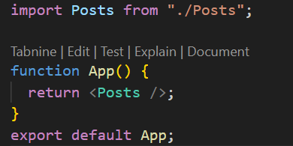

**5. My Academy team at Cognizant want to create a dashboard containing the details of ongoing and completed cohorts. A react application is created which displays the detail of the cohorts using react component. You are assigned the task of styling these react components.**

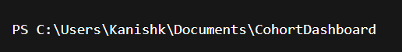

CohortDetails.module.css

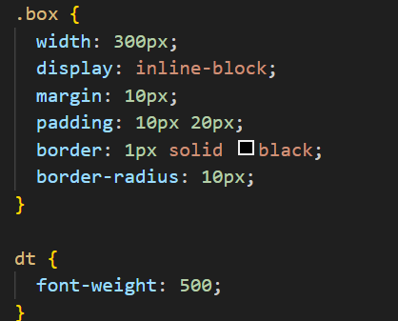

CohortDetails.js

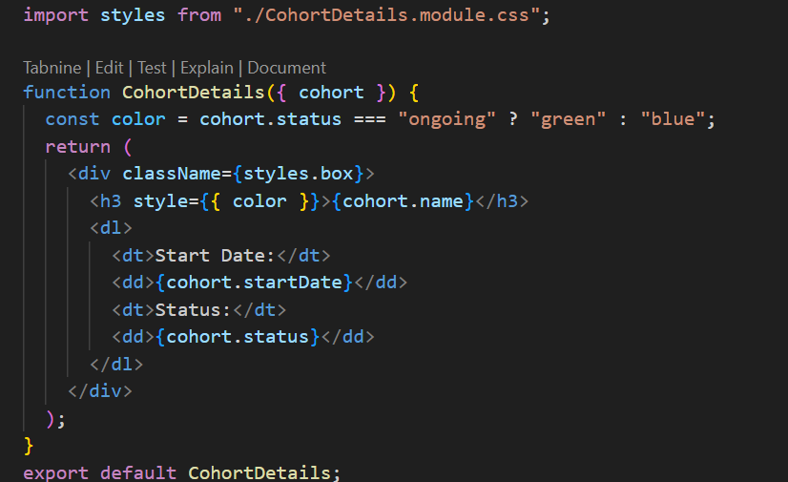

App.js

